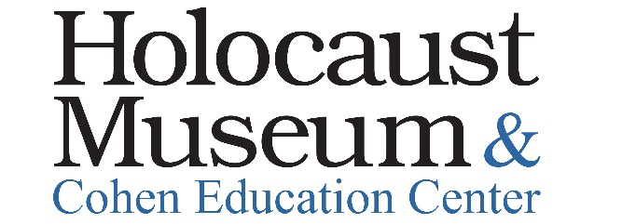

Use this PDF to mail in your membership form and payment.
Membership Price: |  |  |  | $
Please provide your address: | I/we would like to make an additional unrestricted contribution of: |  |  | $
 | Total Enclosed: |  |  | $
 | Make checks payable to: Holocaust Museum & Cohen Education Center
Credit Card #: ___________________________________________
Exp. Date: __________________ Security Code______ __
Signature: ______________________________________________
I authorize payment for the above total.
Please provide your email:
Please provide your tel #:
We don’t sell your email address or phone number.

Membership Levels |  | Name(s) of Adult(s) | # of Children and/or Grandkids | Price
Individual  (1 named Adult) |  |  |  | $45
Family  (2 named Adults + children or grandkids under age 21 years of age) |  |  |  | $70
Sustaining  (2 named Adults + children or grandkids under age 21 years of age) |  |  |  | $250
Builder  (2 named Adults + children and grandkids under 21 years of age) |  |  |  | $1000

Please mail this form with your payment to:

Holocaust Museum & Cohen Education Center
975 Imperial Golf Course Blvd, Suite 108
Naples, FL 34110

Questions? Call us at 239-263-9200 ext. 207 or email us at julie@hmcec.org

Thank you for your support!

